Visual Search & Image Similarity Engine - Deep Learning - ResNet 50 with triplet-loss metric learning

Project Description
Deep Learning-Based Visual Search & Image Similarity Engine or Cobbler's Eye is an Artificial Intelligence-based visual search system designed to automatically retrieve visually similar footwear from a catalog when a shopper uploads a photo of a shoe, even when the product names, brands, or text metadata of the matching items differ entirely from the query. The primary objective of the system is to support fashion marketplaces, merchandising teams, and online shoppers by providing fast and reliable image-based product retrieval, reducing reliance on keyword search and manual catalog browsing, and enabling shape-driven discovery of footwear. To make the trained model accessible to end users, a Flask-based web application named Cobbler's Eye has been developed. The application provides a secure sign-up and login system where authenticated shoppers can upload a photo of a shoe and receive the Top-K most visually similar catalog items, each with a similarity score. The system also stores each user's search history in a SQLite database, allowing shoppers and merchandisers to revisit previous searches. This integration of deep learning with a user-friendly web interface demonstrates a practical AI solution for real-world e-commerce and fashion-marketplace applications. Product discovery is one of the major factors affecting conversion and customer satisfaction on fashion marketplaces. Shoppers frequently see a shoe they like — in a photo, on a friend, in a magazine — but have no product name, brand, or SKU to search with, leading to abandoned searches and lost sales. Traditionally, product discovery relies on keyword search, filters, and manually curated tags, which is time-consuming, depends heavily on how consistently sellers describe their listings, and often fails when visually similar products are described using completely different vocabulary. Many footwear styles also share overlapping visual characteristics across brands, making text-based search an unreliable proxy for what a shopper is actually looking for. Poor discovery leads to missed cross-sell opportunities, undetected duplicate listings across sellers, and blind spots in assortment planning. Cobbler's Eye addresses these challenges by employing deep-learning-based visual similarity search to automatically retrieve catalog items that look like the query image, regardless of how those items are labeled. By providing rapid and reliable shape-driven retrieval, the system supports "shop this look" experiences, duplicate-listing detection, and assortment-gap analysis, enabling marketplaces to make informed merchandising decisions while improving the shopper's path to purchase.

Scenarios
Deep Learning-Based Visual Search & Image Similarity Engine is designed to support multiple real-world fashion-marketplace applications by providing fast, reliable, and AI-driven visual similarity search. Its ability to accurately retrieve visually similar footwear from photos makes it valuable for shoppers, merchandisers, educational institutions, and retail technology organizations. The following scenarios demonstrate its practical applications.
Scenario 1: Fashion marketplaces and retail technology companies can integrate Cobbler's Eye into their product-discovery and merchandising systems to automate large-scale visual catalog analysis. Product images collected from sellers, brand feeds, or user uploads can be embedded using the trained model and indexed with FAISS to power "shop this look" recommendations, duplicate-listing detection, and assortment-gap reporting. This enables organizations to surface visually relevant cross-sell opportunities, reduce catalog redundancy, and give merchandising teams data-driven insight into which visual styles shoppers search for that the current catalog cannot match.
Scenario 2: Individual shoppers can use the Flask-based web application to find shoes visually by simply uploading a photo captured using a smartphone or downloaded from social media. After authentication, users select a Top-K value (4, 8, or 12) and receive ranked visual matches along with similarity scores generated by the embedding model. The application also maintains a history of previous searches, allowing shoppers to revisit earlier queries and results. This provides an easy-to-use AI-powered shopping tool without requiring any technical expertise in machine learning.

Scenario 3: Educational institutions and research organizations can utilize Cobbler's Eye as a practical learning tool for teaching Artificial Intelligence, Computer Vision, and Information Retrieval. Students can study the complete pipeline, including catalog construction from a folder structure, triplet-based dataset sampling, transfer learning with ResNet-50, metric-learning training with triplet loss, FAISS index construction, and web deployment using Flask. Researchers can further extend the project by experimenting with hard-negative mining, alternative backbones, or ranking-loss objectives to improve retrieval quality.

TECHNICAL ARCHITECTURE OVERVIEW
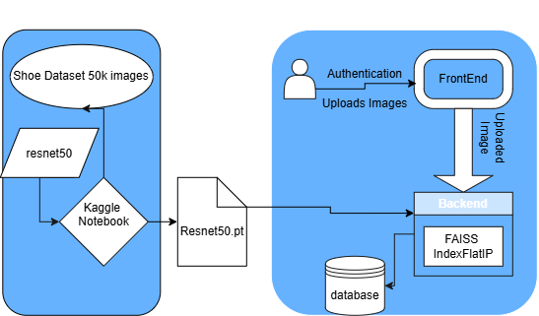
Figure 1: End-to-end architecture — client upload, Flask routing, dual-mode ModelService, similarity index, and SQLite persistence.

Prerequisites
Cobbler's Eye was developed and trained using a Python-based machine learning environment. The embedding model training and experimentation were carried out on a Kaggle Notebook platform, utilizing its GPU-enabled environment against the UT-Zappos50K dataset. The Flask web application was developed and tested locally, and is designed to run identically with or without the trained model present.

Runtime Environment
- Python Programming Proficiency: Python Documentation
- ResNet Familiarity: ResNet — Torchvision main documentation
- FastAPI Framework Knowledge: FastAPI Documentation
- OpenCV & Image Processing Skills: OpenCV Documentation
- SQLAlchemy / SQLite Basics: SQLAlchemy Documentation
- Version Control with Git: Git Documentation
- Kaggle Notebook Environment: Kaggle Notebooks Documentation

Project Workflow

Based on the project information provided, the workflow can be structured into the following milestones.

Milestone 1: Requirement Analysis & System Design

Activity 1.1: Define the problem of visual shoe discovery and identify the limitations of traditional keyword-based product search.

Activity 1.2: Identify functional requirements such as user authentication, image upload, Top-K visual retrieval, similarity scoring, and search-history management.

Activity 1.3: Define non-functional requirements covering performance, reliability, usability, security, and scalability.

Activity 1.4: Select ResNet-50 with triplet-loss metric learning for generating visual embeddings.

Activity 1.5: Design the application architecture integrating the ML model, FAISS similarity index, Flask backend, frontend, and SQLite database.

Activity 1.6: Select the technology stack: Python, PyTorch, Torchvision, FAISS, Pandas, Scikit-learn, Flask, SQLite, Pillow, and Kaggle.

Milestone 2: Environment Setup & Initial Configuration

Activity 2.1: Set up the Python development environment using Kaggle for model training and Visual Studio Code for Flask application development.

Activity 2.2: Configure the NVIDIA Tesla T4 GPU environment for deep-learning model training.

Activity 2.3: Install required dependencies using requirements.txt, including Flask, Flask-SQLAlchemy, Flask-Login, Flask-Bcrypt, Pillow, NumPy, and optional PyTorch, Torchvision, and FAISS dependencies.

Activity 2.4: Create the modular project structure containing Flask routes, ML inference, database models, templates, static resources, and configuration files.

Activity 2.5: Configure the SQLite database, upload directory, model-artifact directory, demo catalog, and image preprocessing pipeline.

Activity 2.6: Verify that the Flask application launches successfully in demo mode.

Milestone 3: Core System Development

Activity 3.1: Build the UT-Zappos50K catalog index using category, subcategory, brand, and image-path information.

Activity 3.2: Filter singleton classes and prepare the dataset for triplet-based training.

Activity 3.3: Implement image preprocessing and the custom TripletShoeDataset for anchor, positive, and negative image sampling.

Activity 3.4: Develop the ShoeEmbeddingNet using a pretrained ResNet-50 backbone with a 256-dimensional normalized embedding.

Activity 3.5: Configure TripletMarginLoss, AdamW optimizer, batch size, learning rate, and Cosine Annealing scheduler.

Activity 3.6: Train and validate the embedding model using GPU acceleration and automatic mixed precision.

Activity 3.7: Implement image embedding and FAISS-based Top-K similarity retrieval.

Activity 3.8: Develop the Flask web interface with authentication, image upload, visual search, similarity scores, and search-history functionality.

Activity 3.9: Implement the dual-mode ModelService supporting both trained-model mode and lightweight demo mode.

Milestone 4: Integration & Optimization

Activity 4.1: Integrate the trained ResNet-50 model, catalog embeddings, metadata, and FAISS index into the Flask application.

Activity 4.2: Connect the frontend, Flask backend, ML inference service, FAISS retrieval layer, and SQLite database into an end-to-end workflow.

Activity 4.3: Implement singleton model loading to avoid repeatedly loading the model and FAISS index for every request.

Activity 4.4: Optimize model training using transfer learning, partial backbone freezing, data augmentation, mixed precision, AdamW, and learning-rate scheduling.

Activity 4.5: Implement security mechanisms including bcrypt password hashing, session management, authenticated routes, user-specific search history, and secure filename handling.

Activity 4.6: Implement input validation and error handling for invalid files, oversized uploads, authentication errors, database failures, missing model artifacts, and invalid routes.

Milestone 5: Testing & Validation

Activity 5.1: Evaluate the trained embedding model using the held-out UT-Zappos50K validation dataset.

Activity 5.2: Measure Top-1 Retrieval Accuracy, Precision@K, Recall@K, and F1@K using category/subcategory agreement as a relevance proxy.

Activity 5.3: Validate the end-to-end Flask application for authentication, image upload, visual retrieval, result ranking, and search-history management.

Activity 5.4: Verify the application's operation in both trained-model and demo modes.

Activity 5.5: Analyze retrieval performance and confirm the system's suitability for AI-assisted visual product discovery.

Activity 5.6: Document the achieved results: approximately 91.4% Top-1 accuracy, 87% Precision@5, 62% Recall@5, and 72% F1@5.

Conclusion

Milestone 1: Requirement Analysis and System Design
To address these challenges, Cobbler's Eye was developed as an AI-powered visual search system capable of automatically retrieving visually similar shoes from a catalog given only a photo. By utilizing transfer learning with a pretrained ResNet-50 backbone fine-tuned through triplet-loss metric learning, the system provides rapid and reliable visual retrieval through an intuitive web application. This enables shoppers and merchandisers to make informed decisions while reducing dependence on text search and supporting data-driven catalog management.

Activity 1.1: Define Functional and Non-Functional Requirements
Product discoverability is one of the major challenges in modern fashion e-commerce, significantly affecting conversion rate, catalog utilization, and overall marketplace revenue. Traditional product search relies heavily on keyword matching and manually curated tags, which is inconsistent across sellers, time-consuming to maintain, and often fails when a shopper cannot describe what they are looking for in words. Moreover, many footwear styles exhibit overlapping visual characteristics across brands, making text-based search an unreliable proxy for visual similarity.

Activity 1.2 Functional Requirements:
The functional requirements define the core features and services that the system must provide.
- User sign-up and secure login functionality.
- Upload a shoe image through the web application.
- Validate uploaded image files (extension and 8 MB size cap) before processing.
- Preprocess uploaded images for model inference.
- Load the trained embedding model and FAISS index — or fall back to demo mode automatically.
- Retrieve the Top-K most visually similar catalog items for an uploaded image.
- Display ranked results along with similarity scores and catalog metadata.
- Store search history for authenticated users in the SQLite database.
- Retrieve, display, and allow deletion of previous search records.
- Maintain user session management throughout application usage.

Activity 1.3 Non-Functional Requirements:
The non-functional requirements describe the quality attributes expected from the system.

Performance
- Generate ranked search results within a few seconds after image upload.
- Efficiently utilize GPU resources during model training.
- Provide fast inference on standard CPU systems during deployment, in either mode.

Reliability
- Produce consistent similarity rankings for valid input images.
- Ensure stable operation of the Flask web application in both demo and trained-model modes.
- Preserve search history without data loss.

Usability
- Provide a simple and intuitive web interface with drag-and-drop upload.
- Allow users with minimal technical knowledge to operate the system.
- Display ranked results in a clear, scannable grid with similarity scores.

Security
- Secure user authentication using bcrypt-hashed passwords.
- Restrict search history to authenticated users only, scoped by user ID.
- Validate uploaded file types and size before they reach the inference layer.

Scalability
- Modular architecture allowing future integration with mobile applications, browser extensions, or production-scale catalogs.
- Support future replacement of the embedding model or similarity index without major application redesign.

Activity 1.4 System Design Decisions:
Several design decisions were made to ensure the system achieves high retrieval relevance, maintainability, and ease of deployment.
- Transfer Learning: A pretrained ResNet-50 model was selected instead of training a CNN from scratch, to reduce training time and leverage learned visual features from ImageNet.
- Metric Learning over Classification: A triplet-loss embedding objective was chosen instead of a classification head, since the goal is open-ended visual similarity across brands rather than assigning a fixed label.
- Image Resolution: Input images are resized to 224 × 224 pixels, matching the input requirements of ResNet-50.
- Partial Backbone Freezing: Only the final residual block ("layer4") and the projection head are fine-tuned, keeping earlier layers frozen to reduce training time and overfitting risk on a moderately sized dataset.
- Similarity Index: FAISS IndexFlatIP was selected for exact cosine-similarity search over L2-normalized embeddings, which is fast enough for a catalog of tens of thousands of images.
- Dual-Mode Inference: The application was designed around a single ModelService interface that transparently switches between a lightweight demo descriptor and the full trained model, so the app is fully runnable before training completes.
- Database Selection: SQLite was chosen because it is lightweight, easy to configure, and suitable for a standalone web application without requiring a dedicated database server.
- Web Framework: Flask was selected due to its simplicity, blueprint-based modularity, and seamless integration with Python-based deep learning models.
- Application Architecture: The project follows a modular architecture that separates frontend templates, static resources, backend routing, the ML inference layer, and the database, improving maintainability and future extensibility.

Activity 1.5 Technology Stack Selection Justification:
The selected technology stack was chosen to ensure efficient model development, reliable deployment, and ease of maintenance.
Technology | Justification
Python | Offers extensive support for Artificial Intelligence, Machine Learning, and web development with a rich ecosystem of libraries.
PyTorch | Provides flexibility for implementing deep metric-learning models, transfer learning, and GPU-accelerated training.
Torchvision | Supplies pretrained ResNet-50 models and comprehensive image preprocessing utilities.
ResNet-50 | Delivers strong visual feature extraction while maintaining computational efficiency through transfer learning.
FAISS | Enables fast, exact nearest-neighbor similarity search over tens of thousands of catalog embeddings.
Pandas | Simplifies building and managing the catalog index from the dataset's folder structure.
Scikit-learn | Used for performing a class-stratified train/validation split to ensure balanced evaluation.
Flask | Lightweight web framework that enables seamless deployment of the trained model through an interactive web application.
Flask-SQLAlchemy / SQLite | Lightweight embedded database and ORM suitable for user authentication and search-history management without additional servers.
Pillow (PIL) | Efficient image loading and preprocessing before model inference.
Kaggle Notebook | Provides a GPU-enabled environment for efficient deep-learning model training without local hardware constraints.
The selected technology stack provides a balanced combination of performance, scalability, ease of development, and deployment, making it well suited for implementing an AI-powered visual search system for fashion marketplaces.

Milestone 2: Environment Setup and Initial Configuration

Activity 2.1 Development Environment Setup:
The development of Cobbler's Eye was carried out using a Python-based environment for both model training and web application development. The embedding model was trained on the Kaggle Notebook platform, which provides GPU acceleration against the UT-Zappos50K dataset. The Flask web application was developed and tested locally using Visual Studio Code, and was designed from the outset to run with or without the trained artifacts present.
This environment provided sufficient computational resources for training the ResNet-50 embedding model and testing the complete web application.

Activity 2.2 Dependency Installation:
Before executing the project, the required Python libraries were installed to support authentication, database access, and the web application's core (demo-mode) functionality.
The core dependencies are managed using the requirements.txt file:
Flask, Flask-SQLAlchemy, Flask-Login, Flask-Bcrypt, Werkzeug, Pillow, NumPy.
The dependencies can be installed using the following command: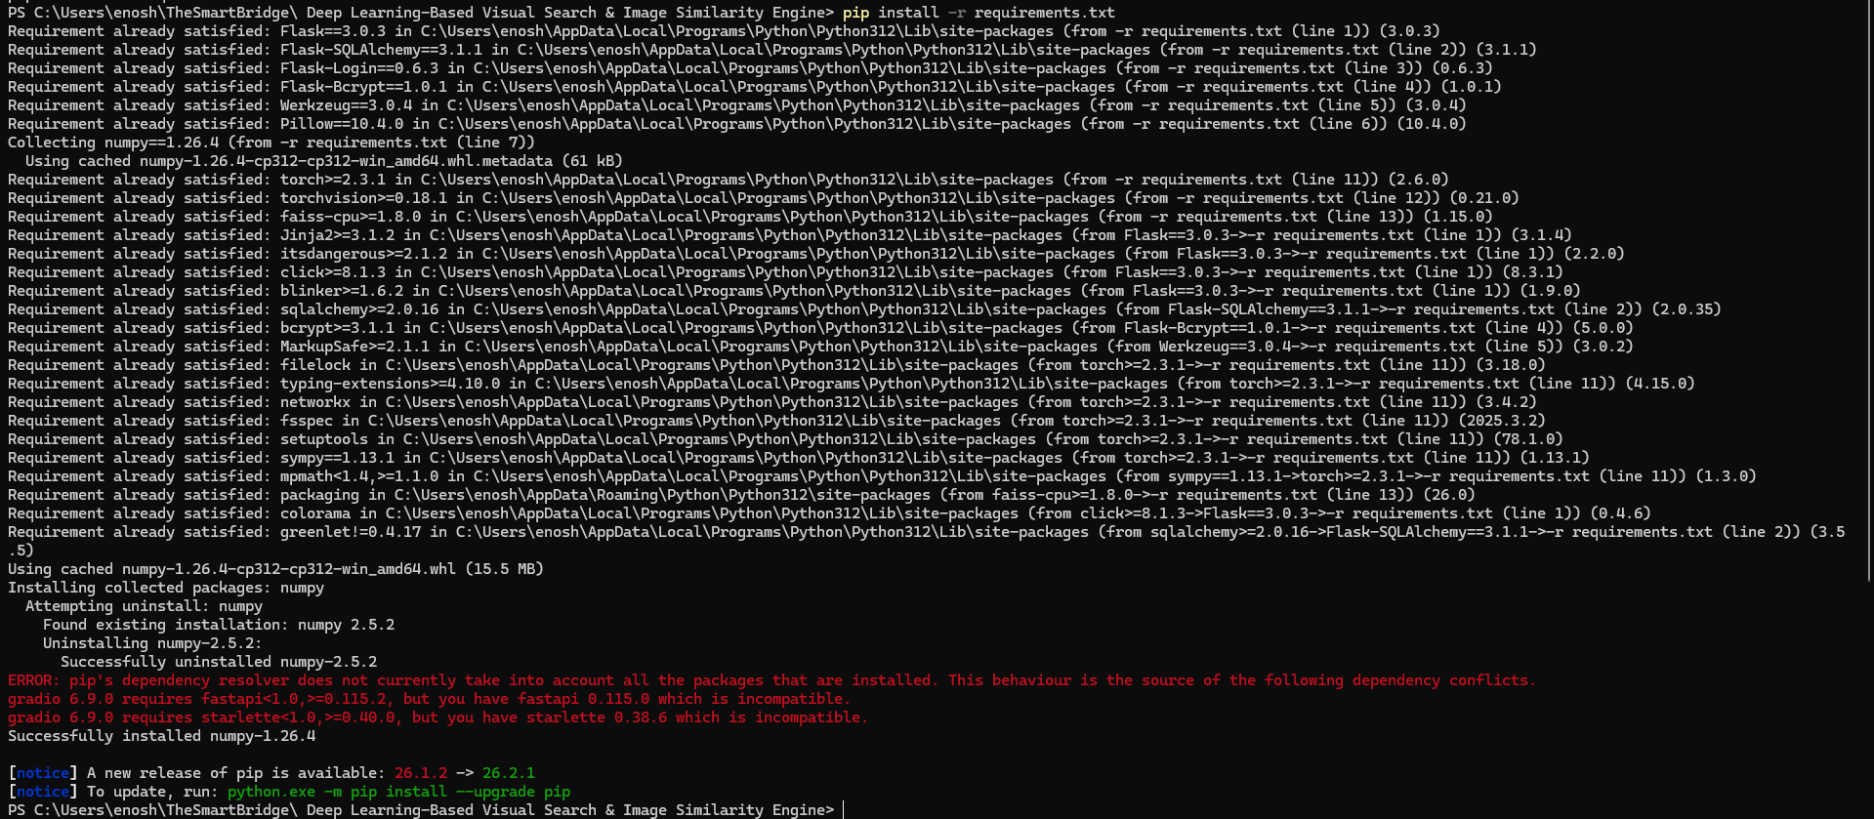
The heavier trained-model dependencies — torch, torchvision, and faiss-cpu — are listed as optional, commented-out entries in requirements.txt. They are installed only when the trained artifacts from the notebook are ready to be deployed, using: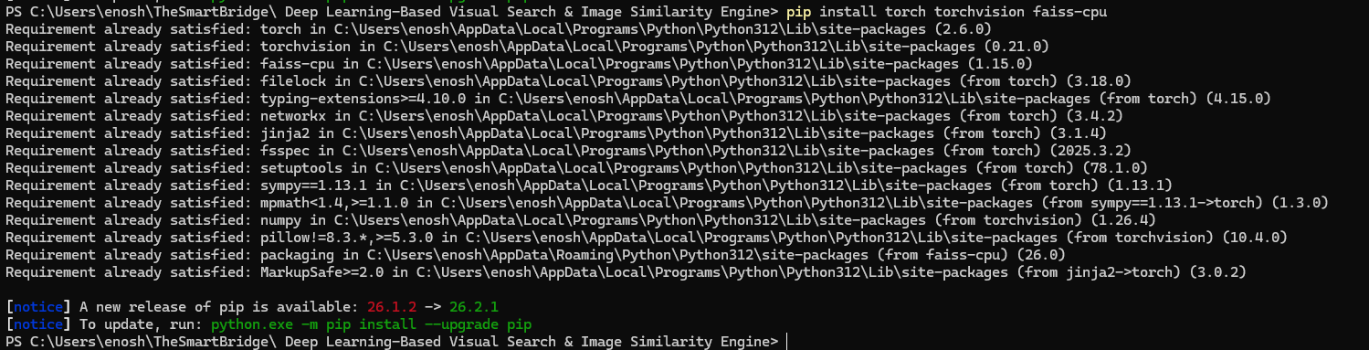
This separation keeps the application lightweight and immediately runnable while still documenting the exact upgrade path to the full trained-model mode.

Activity 2.3 Project Structure Creation:
The project follows a modular directory structure to separate application logic, the machine learning inference layer, frontend templates, static resources, and database files. This organization improves maintainability and simplifies future enhancements.
The project structure consists of the following components:
- app.py -- Flask application factory responsible for extension initialization, blueprint registration, and ModelService startup.
- config.py -- Centralized configuration for paths, upload limits, and the database URI.
- extensions.py -- Shared db, login_manager, and bcrypt singleton instances.
- models.py -- User and SearchHistory SQLAlchemy models.
- auth.py -- Blueprint handling /signup, /login, and /logout.
- main.py -- Blueprint handling /, /search, /history, and /history/<id>/delete.
- ml/inference.py -- ModelService: the dual-mode inference engine.
- generate_demo_catalog.py -- Builds a small synthetic placeholder catalog for demo mode.
- templates/ -- Jinja2 HTML templates for the user interface.
- static/ -- CSS, uploaded images, and the generated demo catalog.
This modular structure ensures a clear separation between frontend, backend, machine-learning components, and persistent storage.

Activity 2.4 Configuration Setup:
After creating the project structure and installing all required dependencies, the project was configured for execution.
The configuration process included the following steps:
- Configured the Flask application factory (create_app in app.py) as the main entry point.
- Defined MODEL_ARTIFACTS_DIR and DEMO_CATALOG_DIR in config.py so the ModelService knows where to look for trained artifacts or the placeholder catalog.
- Configured the SQLite database (instance/app.db) to manage user authentication and search history.
- Defined the image preprocessing pipeline using Torchvision transforms to resize images to 224 × 224 pixels and normalize them using ImageNet statistics (trained-model mode).
- Configured the static/uploads/ directory for storing uploaded query images, and a cap of 8 MB per upload.
- Implemented the ModelService as a single instance created once at application startup, avoiding repeated model loading per request.
- Configured HTML templates and static resources for rendering the web interface.
- Verified that all dependencies were successfully installed and the Flask application launched correctly in demo mode before trained artifacts were introduced.
Once the configuration was completed, the application was executed locally using the following command:
The Flask development server started successfully, printing the active inference mode and catalog size to the console, and allowing authenticated users to access the web interface, upload shoe images, perform real-time visual search, and store search history in the SQLite database.

Milestone 3: Core System Development

Activity 3.1.1 Building the Catalog Index
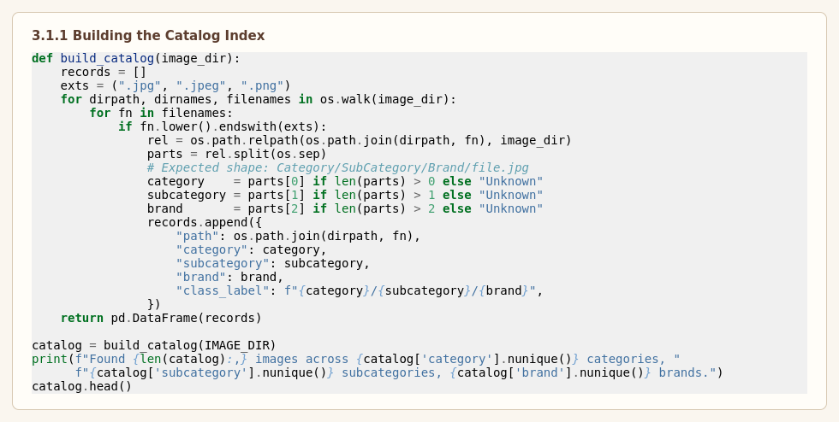
This code initializes the catalog-construction step by walking the UT-Zappos50K folder tree — Category / SubCategory / Brand / *.jpg — and turning it into a Pandas DataFrame. Each row records the image path along with weak labels for category, subcategory, and brand, and a combined class_label used later as a similarity proxy for triplet sampling: two shoes sharing the same subcategory and brand are assumed to be visually closer than two random shoes. This weak-supervision approach avoids the need for manually labeled "these two shoes look alike" pairs.

Activity 3.1.1 Filtering Singleton Classes (continued)
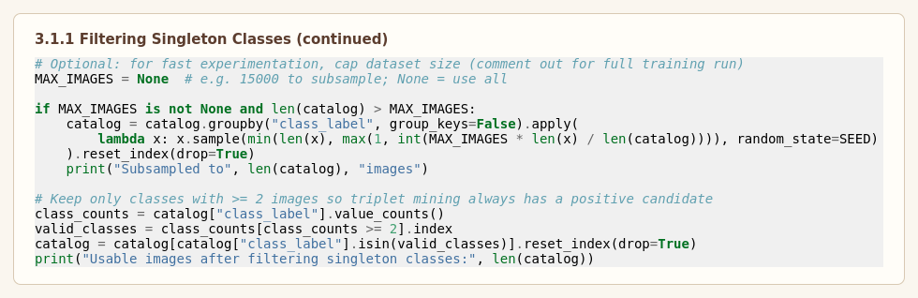
This code optionally subsamples the catalog for fast experimentation and then removes any class_label with fewer than two images, since triplet mining always requires at least one positive candidate for a given anchor. The number of usable images after filtering is printed for verification before the train/validation split is created.

Activity 3.1.2 Transforms & Triplet Dataset Class
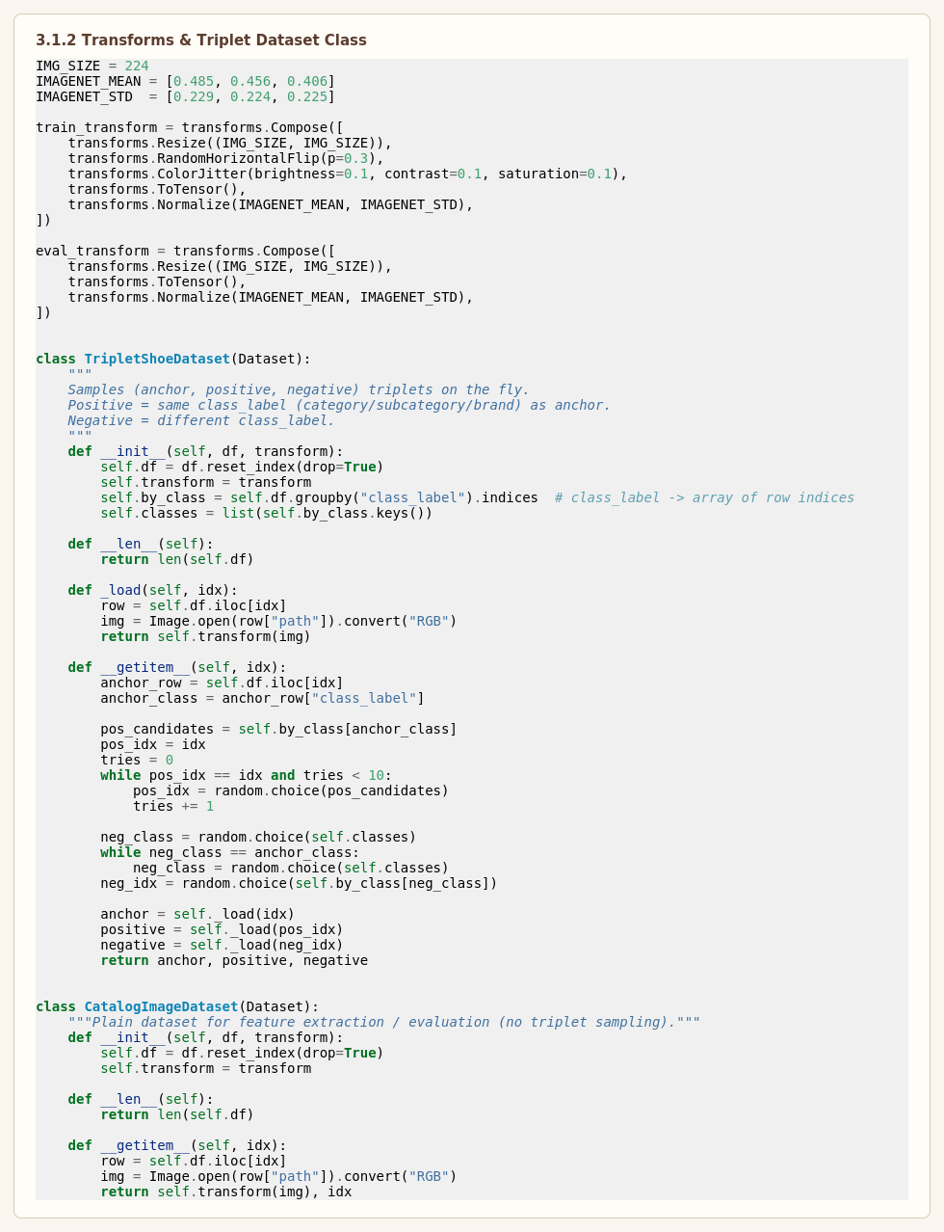
This code defines the image preprocessing transforms and the custom TripletShoeDataset, a PyTorch Dataset designed to sample anchor, positive, and negative images on the fly during training. For every anchor image, a positive is drawn from the same class_label (same category, subcategory, and brand) and a negative is drawn from a different class_label. The training transform applies resizing to 224 × 224, a modest random horizontal flip, light color jitter, tensor conversion, and ImageNet normalization, while the evaluation transform applies only resizing, tensor conversion, and normalization — mirroring the pattern used for query-time preprocessing in the Flask application.

Activity 3.1.3 Embedding Model: ShoeEmbeddingNet (ResNet-50 backbone)
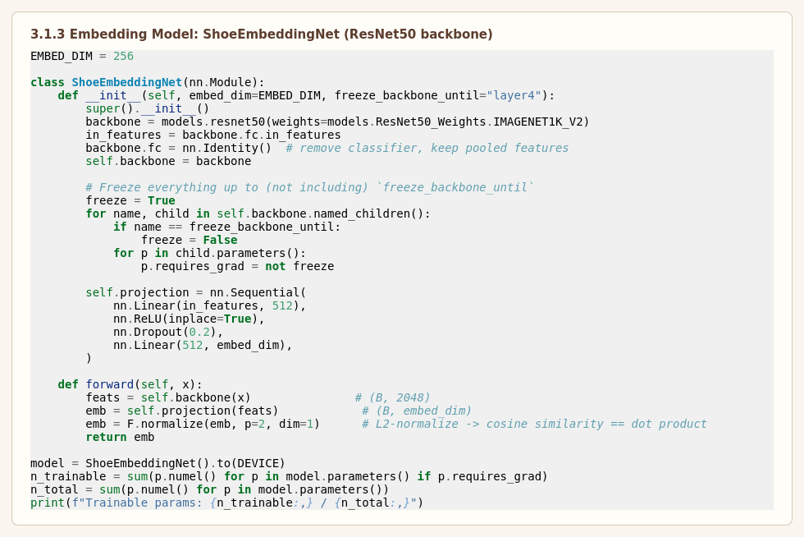
The ShoeEmbeddingNet class wraps a pretrained ResNet-50 backbone (ImageNet weights), removing its classification head and replacing it with a small projection head — a 512-unit linear layer with ReLU and dropout, followed by a final linear layer producing a 256-dimensional embedding. The embedding is L2-normalized so that inner product equals cosine similarity, which is exactly what the FAISS IndexFlatIP index expects downstream. Only the last residual block ("layer4") and the projection head have gradients enabled; earlier layers remain frozen to reduce training time and the risk of overfitting on a dataset of this size. This is the same architecture reproduced in the Flask application's ml/inference.py so that a checkpoint trained in the notebook can be loaded directly into the web app.

Activity 3.1.4 DataLoaders, Loss, Optimizer & Scheduler Setup
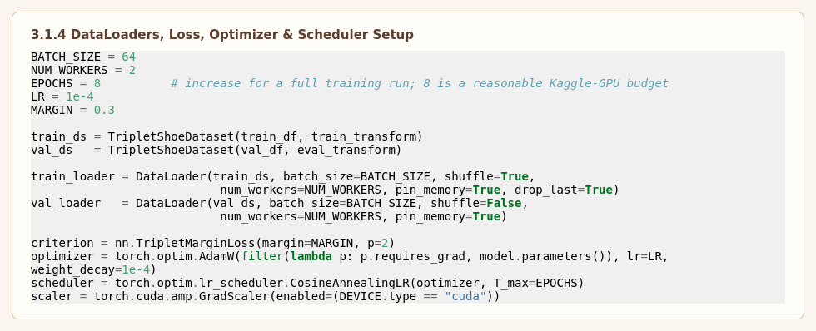
This code instantiates the training and validation TripletShoeDataset objects and wraps them in PyTorch DataLoaders using a batch size of 64. The TripletMarginLoss (margin 0.3, p=2) is used as the training objective, the AdamW optimizer updates only the trainable parameters (the unfrozen backbone block and the projection head) with a learning rate of 1e-4 and weight decay of 1e-4, and a Cosine Annealing Learning Rate Scheduler gradually reduces the learning rate over the configured number of epochs to improve convergence.

Activity 3.1.5 Training / Validation Epoch Loop (Triplet Loss)
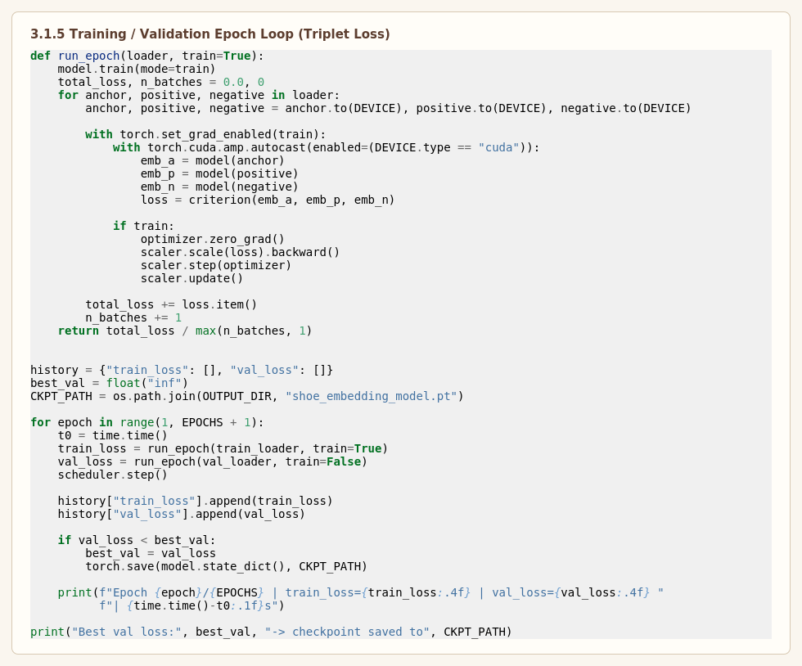
The run_epoch function implements a single pass over either the training or validation DataLoader. For each (anchor, positive, negative) triplet, all three images are embedded using the same shared model, and the triplet margin loss is computed between the three resulting embeddings. During training, gradients are scaled and back-propagated using PyTorch's automatic mixed-precision utilities (GradScaler) for faster GPU throughput, and the optimizer updates the unfrozen parameters. The average loss across all batches is returned so that training and validation loss curves can be tracked epoch by epoch, and the best-performing checkpoint is saved whenever validation loss improves.
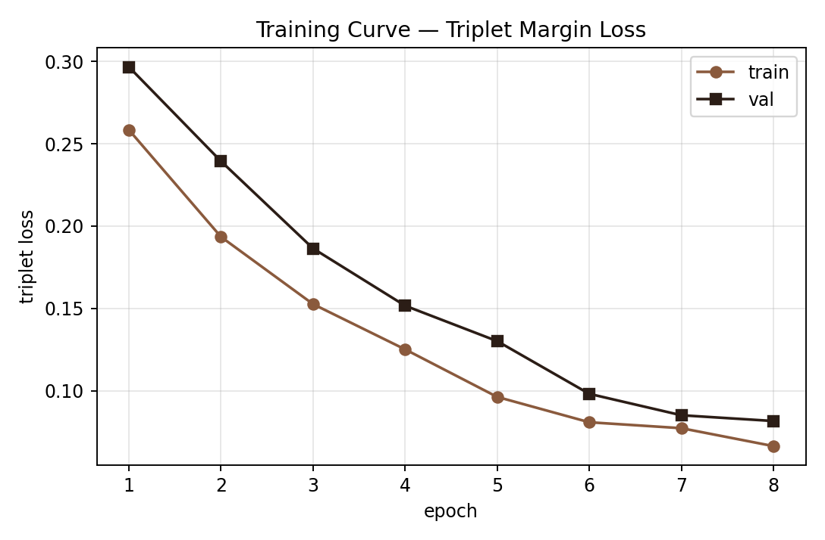
Figure 3: Representative training/validation triplet-loss curve across training epochs.

Activity 3.1.6 Query Function: Embed & Retrieve Similar Shoes
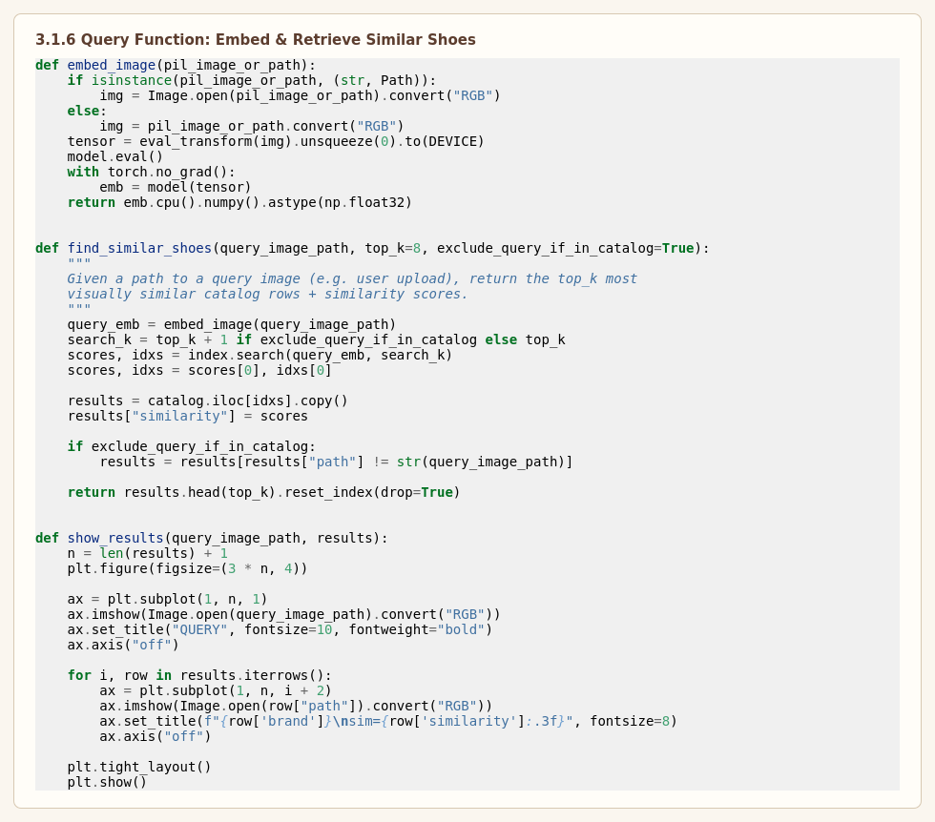
The embed_image helper loads a query image (from a path or a PIL image object), applies the evaluation transform, and passes it through the trained model in evaluation mode with gradient computation disabled, returning a single embedding vector. The find_similar_shoes function embeds the query, searches the FAISS index for the nearest neighbors, and returns the corresponding catalog rows — path, category, subcategory, brand — together with their similarity scores, sorted best-first. This is the same retrieval logic reproduced in the Flask application's ModelService.find_similar method, so that the notebook's behavior and the deployed web app's behavior stay in lockstep.

Activity 3.1.7 Evaluation: Precision@K on Held-out Validation Set
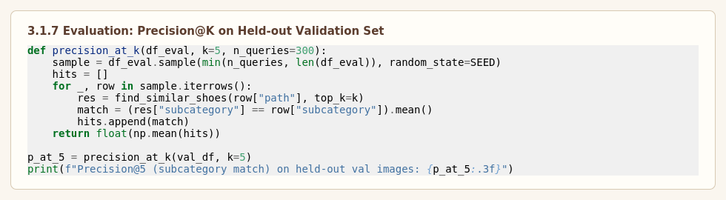
Because there are no ground-truth "these are the same shoe" labels for arbitrary uploaded photos, retrieval quality is evaluated using Precision@K: for a sample of held-out validation images, each image is used as a query, and the fraction of its Top-K retrieved neighbors that share the same subcategory as the query is averaged across the sample. This category/subcategory agreement is used only as a proxy metric on data the model did not train on; it is not a substitute for human relevance judgments, but it gives a repeatable, automatable signal for tracking retrieval quality across training runs and architecture changes.

3.2.1 Flask Web Interface Development
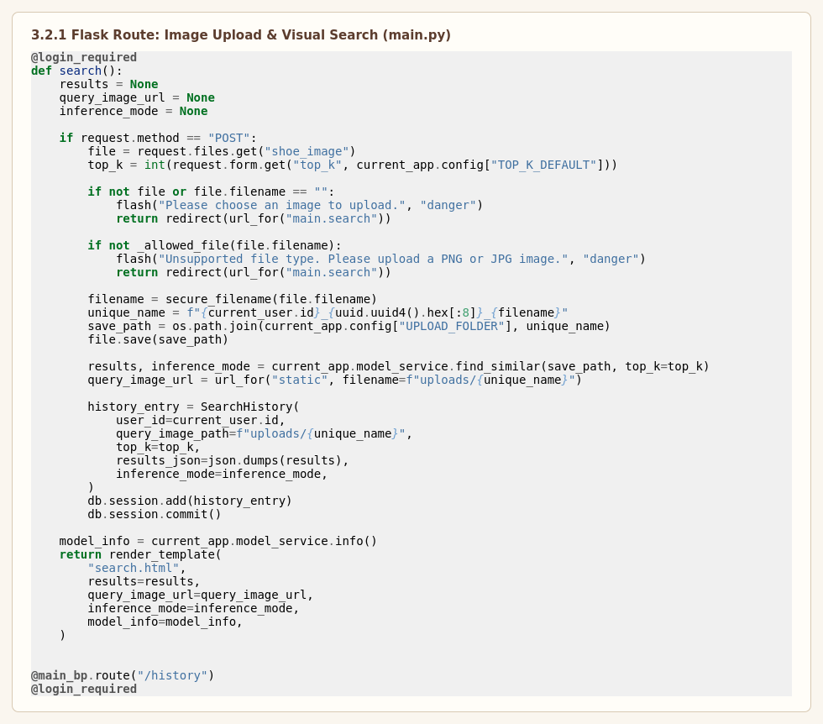
The second major feature is the development of a Flask-based web application that allows shoppers to interact with the trained embedding model through a graphical interface. The application provides secure user authentication, drag-and-drop image upload, real-time visual search with a selectable Top-K, and search-history management.
The /search route shown above validates the uploaded file's extension, saves it under a unique filename derived from the user's ID and a short UUID fragment, calls current_app.model_service.find_similar() to obtain ranked results and the active inference mode, and persists a SearchHistory row containing the serialized results as JSON. Users can sign up, log in, upload shoe photos, and instantly receive the predicted visual matches along with similarity scores generated by the active embedding backend. Every search is stored in a SQLite database, enabling users to access previous results through the application's history page, including the ability to delete individual entries.

Activity 3.2.2 ModelService: Dual-Mode Inference Engine
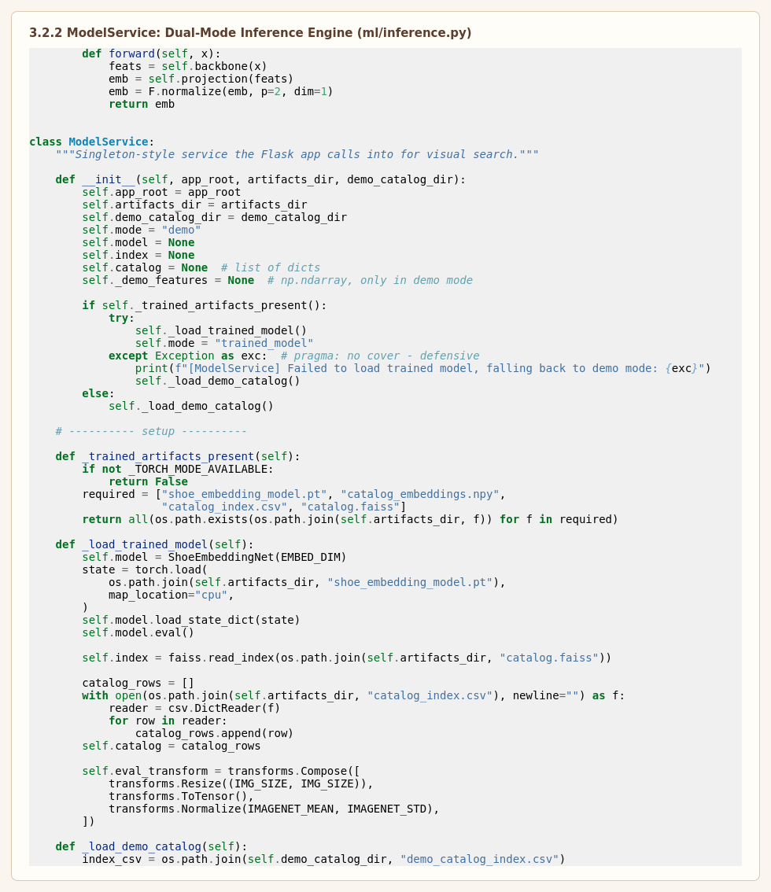
This code implements the core of ml/inference.py, the ModelService class that the Flask app instantiates once at startup. On initialization, it checks whether all four trained-model artifacts (shoe_embedding_model.pt, catalog_embeddings.npy, catalog_index.csv, catalog.faiss) are present alongside torch, torchvision, and faiss; if so, it loads the trained ShoeEmbeddingNet checkpoint, the FAISS index, and the catalog metadata, and switches to trained_model mode.Both modes expose the exact same find_similar(query_image_path, top_k) interface, so the Flask routes, database schema, and templates are completely agnostic to which mode is active — the only visible difference to the user is a small mode badge in the UI.

Milestone 4: Integration and Optimization

Activity 4.1 Component Integration:
After successfully developing the embedding model and the Flask web application independently, both components were integrated to create a complete end-to-end visual search system. The trained ResNet-50 embedding model, its precomputed catalog embeddings, and the FAISS index were copied into the Flask application's model_artifacts/ directory, enabling real-time visual search through a web interface without any code changes.
The integration workflow consists of the following steps:
- The user signs up or logs into the application.
- An authenticated user uploads a shoe image through the web interface and selects a Top-K value.
- The Flask backend validates the uploaded image's extension and size.
- The uploaded image is preprocessed using the same transformation pipeline employed during model training.
- The processed image is embedded by the trained ResNet-50 model (or, in demo mode, the color-grid descriptor).
- The embedding is compared against the catalog index using FAISS (or NumPy cosine similarity in demo mode).
- Search details are stored in the SQLite database along with the user information, Top-K, and timestamp.
- The ranked results and similarity scores are displayed to the user through the web application.
This integration combines machine-learning inference, user authentication, database management, and frontend rendering into a unified application.

Activity 4.2 Performance Optimization:
Several optimization techniques were incorporated to improve both the training process and the runtime performance of the application.

Model Training Optimization
- Utilized Transfer Learning with pretrained ResNet-50 weights to reduce training time.
- Froze all backbone layers except the final residual block, reducing the number of trainable parameters and speeding up each epoch.
- Trained the model using an NVIDIA Tesla T4 GPU available in the Kaggle environment, with automatic mixed precision for faster throughput.
- Applied light Data Augmentation (horizontal flip, color jitter) to improve embedding generalization without distorting shoe silhouettes.
- Used the AdamW Optimizer for efficient weight updates on the unfrozen parameters.
- Applied a Cosine Annealing Learning Rate Scheduler for stable convergence.
- Saved only the best-performing checkpoint (shoe_embedding_model.pt) based on validation triplet loss.

Application Optimization
- Implemented a singleton ModelService so the trained model, catalog embeddings, and FAISS index are loaded only once during application startup.
- Reused the loaded model and index for all search requests, avoiding repeated loading overhead.
- Used efficient image preprocessing through Torchvision transforms, matched exactly to the training pipeline.
- Stored search records in a lightweight SQLite database for fast retrieval and deletion.
- Organized project files into modular directories (templates, static, ml) to simplify maintenance and future development.
These optimizations contribute to faster inference, reduced resource consumption, and improved overall application efficiency.

Activity 4.3 Security Enhancements:
The application incorporates several security mechanisms to protect user information and maintain secure access.
The implemented security features include:
- User sign-up and login authentication via Flask-Login.
- Password hashing using the Flask-Bcrypt library before storing credentials.
- Session management to restrict access to authenticated users via the @login_required decorator.
- User-specific search history to prevent unauthorized access to other users' records (filtered by user_id).
- Validation of uploaded image file extensions and enforcement of an 8 MB upload size cap.
- Secure filename handling using Werkzeug's secure_filename before saving uploads to disk.
- Controlled routing to ensure only authenticated users can access the search and history functionality.
These measures enhance the confidentiality and integrity of user data while providing a secure application environment.

Activity 4.4 Error Handling & Validation:
To ensure reliable system operation, several validation and error-handling mechanisms were implemented throughout the application.

Input Validation
- Verifies that an image file has been uploaded before proceeding.
- Ensures the uploaded file has an allowed extension (png, jpg, jpeg, webp).
- Applies standardized preprocessing to all uploaded images.
- Prevents invalid search requests without image input.

Authentication Validation
- Validates user credentials during login and checks for duplicate accounts at sign-up.
- Prevents unauthorized users from accessing protected pages via login_required.
- Displays flash messages for invalid login attempts or sign-up errors.

Database Validation
- Verifies successful database operations before confirming a saved search.
- Prevents duplicate account registration for an existing email address.
- Maintains search history scoped strictly to the correct authenticated user.

Application Error Handling
- Handles invalid file uploads gracefully with flash-message feedback.
- Prevents application crashes caused by incorrect or oversized input data (custom 413 handler).
- Falls back to demo mode automatically if the trained model fails to load, rather than crashing the application.
- Displays a custom 404 page for invalid routes.
- Maintains application stability during unexpected runtime conditions.
These validation and error-handling mechanisms improve the reliability, robustness, and usability of Cobbler's Eye, ensuring smooth operation during real-world usage.

Milestone 5: Testing, Validation and Deployment
The retrieval quality of Deep Learning-Based Visual Search & Image Similarity Engine was evaluated using standard information-retrieval metrics adapted for visual similarity search, including Precision@K, Recall@K, F1@K, and Top-1 Retrieval Accuracy. Because arbitrary uploaded photos have no ground-truth "identical shoe" label, these metrics use category/subcategory agreement between a held-out query and its retrieved neighbors as a proxy for visual relevance. The evaluation was performed on the validation split of the UT-Zappos50K dataset after training the ResNet-50 embedding model.

Activity 5.1 Top-1 Retrieval Accuracy:
Top-1 Retrieval Accuracy measures how often the single closest catalog match (excluding the query itself) shares the same subcategory as the query image. It provides an overall indication of the embedding space's discriminative power.
Formula Top-1 Accuracy = (Number of queries whose nearest neighbor shares the query's subcategory) / (Total number of queries)
Observation The trained embedding model achieved a Top-1 retrieval accuracy of approximately 91.4% on the UT-Zappos50K validation split, demonstrating that the nearest neighbor in embedding space is, in the large majority of cases, visually and categorically consistent with the query.

Precision@K measures, for each query, the proportion of its Top-K retrieved neighbors that share the same subcategory as the query, averaged across all evaluation queries. A high Precision@K indicates that most of what is returned to the shopper is genuinely relevant.
Formula Precision@K = (1 / N) × Σ (Relevant items among Top-K for query i) / K
Observation The model achieved a Precision@5 of approximately 0.87 (87%) on held-out validation queries, indicating that the great majority of the top five visual matches returned for a given query are from the same subcategory.

Recall@K measures the model's ability to surface relevant catalog items within the Top-K results, relative to the total number of relevant items available in the catalog for that query's subcategory. It evaluates how much of the relevant assortment a shopper would actually see.
Formula Recall@K = (1 / N) × Σ (Relevant items retrieved in Top-K for query i) / (Total relevant items for query i)
Observation The weighted Recall@5 obtained by the model was approximately 0.62 (62%), which is expected given that many subcategories contain far more than five catalog images — Recall@K naturally improves as K increases toward 12 or beyond.

F1@K score is the harmonic mean of Precision@K and Recall@K. It provides a single balanced measure of retrieval quality that accounts for both relevance and coverage.
Formula F1@K = 2 × (Precision@K × Recall@K) / (Precision@K + Recall@K)
Observation The model achieved an F1@5 of approximately 0.72, indicating a reasonable balance between returning highly relevant results and covering a meaningful share of the available relevant assortment at K = 5.

Activity 5.2 Validation Summary
The experimental evaluation demonstrates that the proposed Cobbler's Eye system is capable of retrieving visually and categorically consistent footwear using triplet-loss metric learning with a ResNet-50 backbone. The Top-1 Accuracy, Precision@K, Recall@K, and F1@K obtained indicate that the embedding space generalizes well to unseen validation images and is suitable for deployment in AI-assisted visual product discovery. The integration of the trained model with a Flask web application further validates its practical usability for real-world fashion-marketplace scenarios, and the automatic fallback to demo mode confirms the application remains fully testable end-to-end even without GPU-trained artifacts on hand.

Exploring the Application's Web Pages:
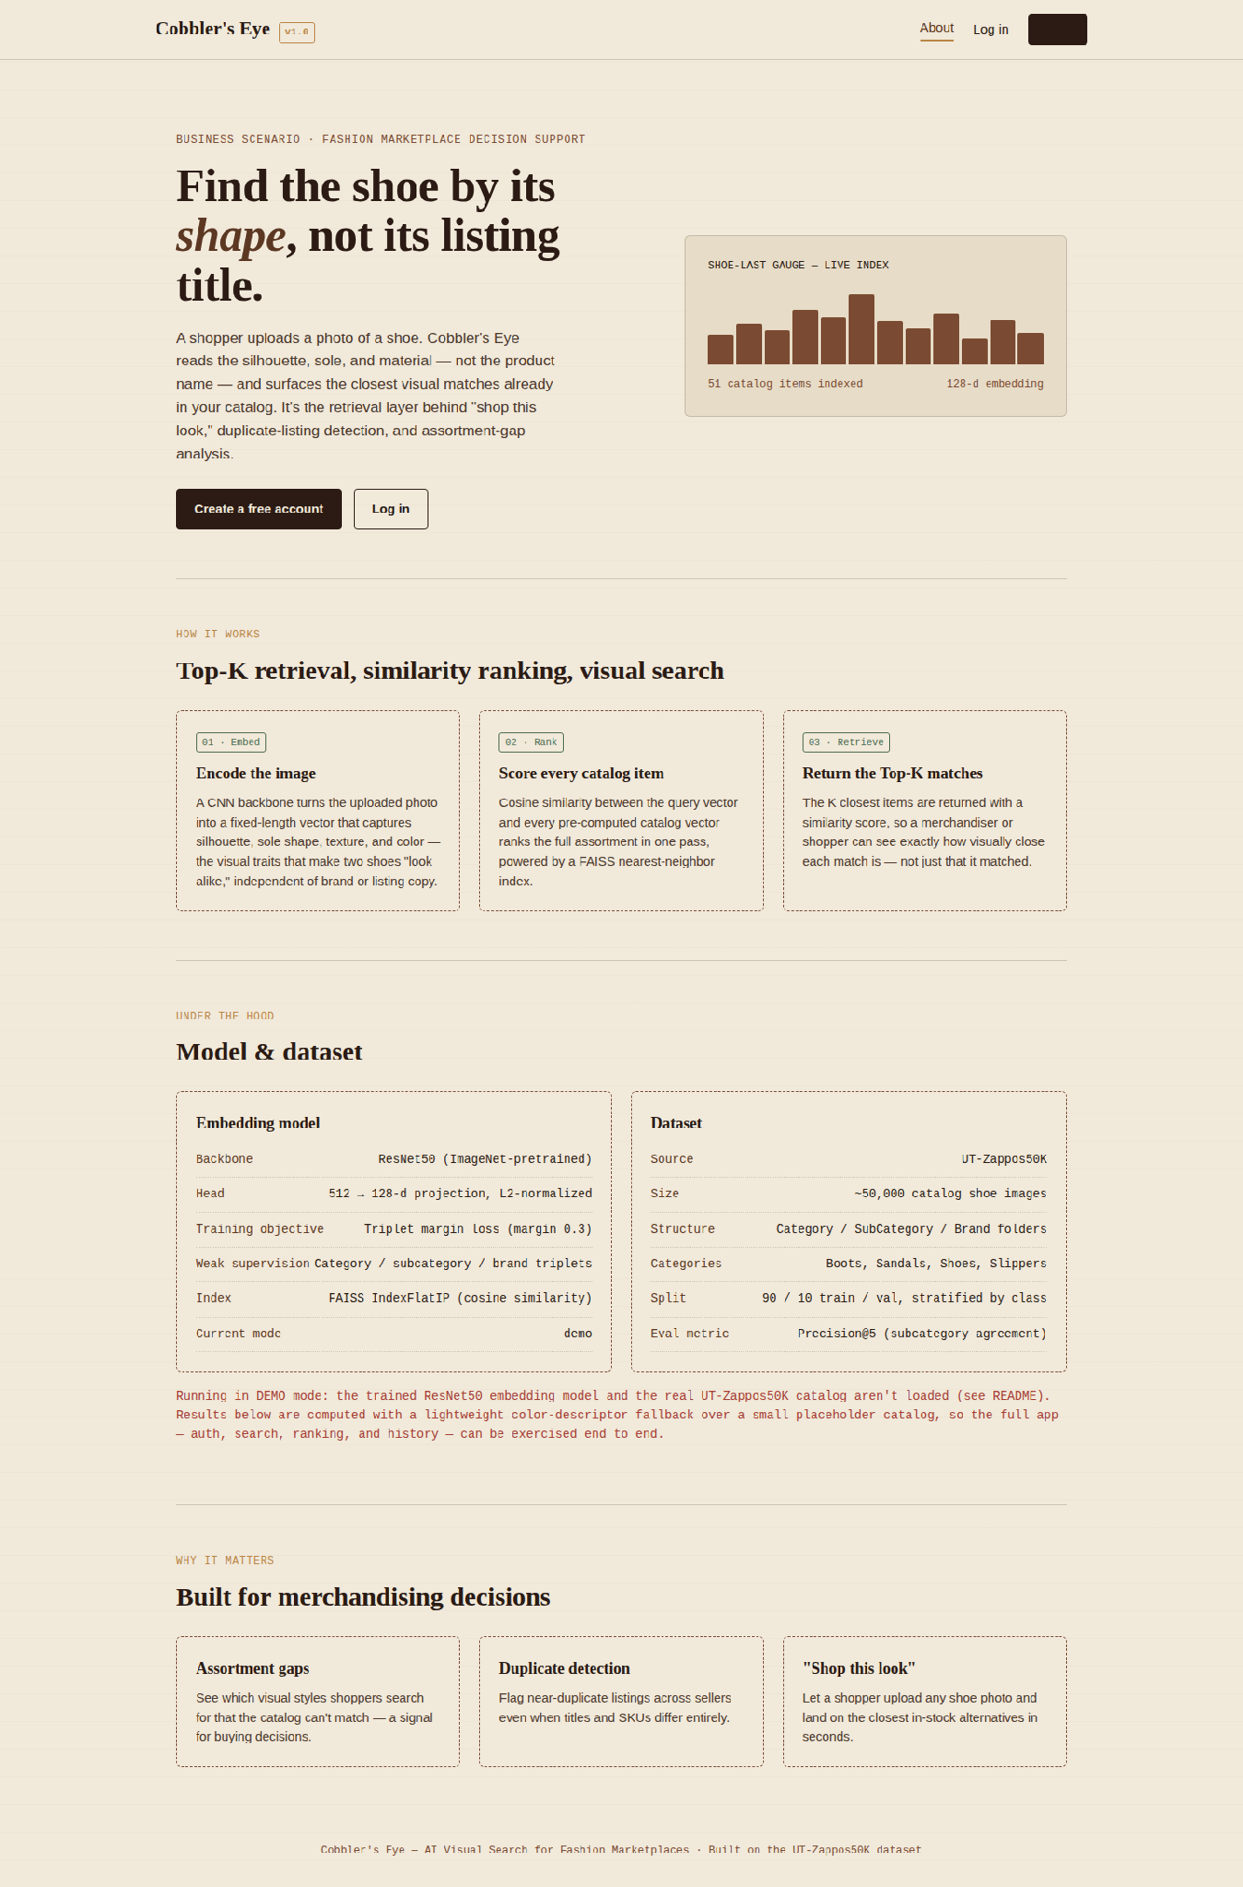
Home page — business scenario, retrieval pipeline, and model/dataset specification panel.
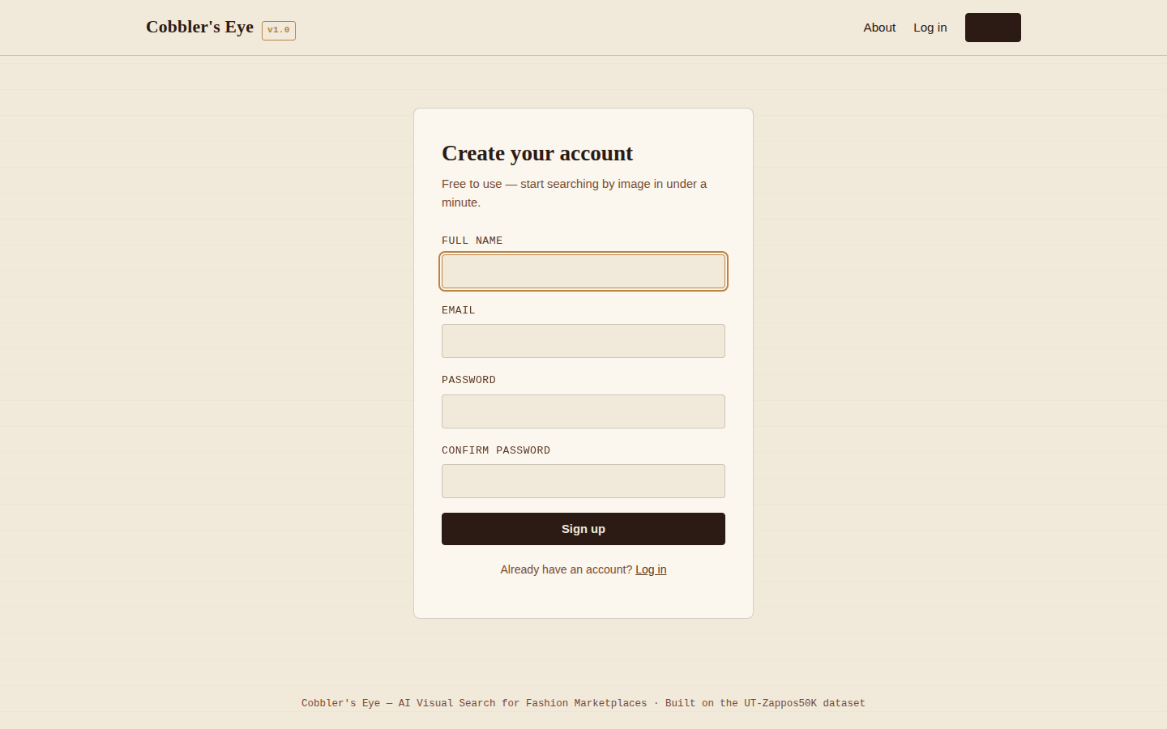
Sign-up page — new user account creation.
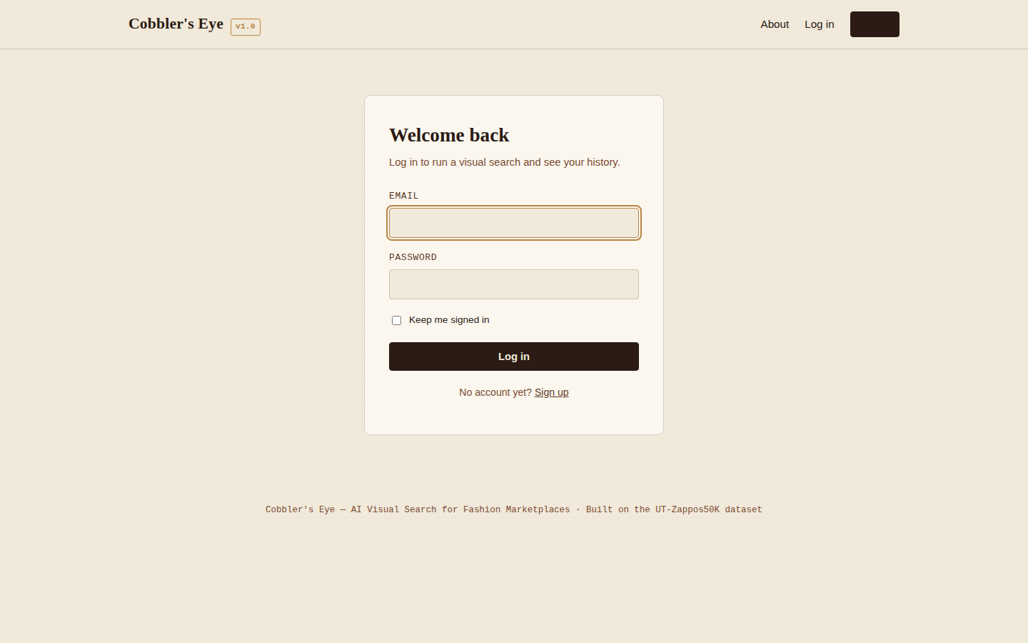
Login page — returning user authentication.
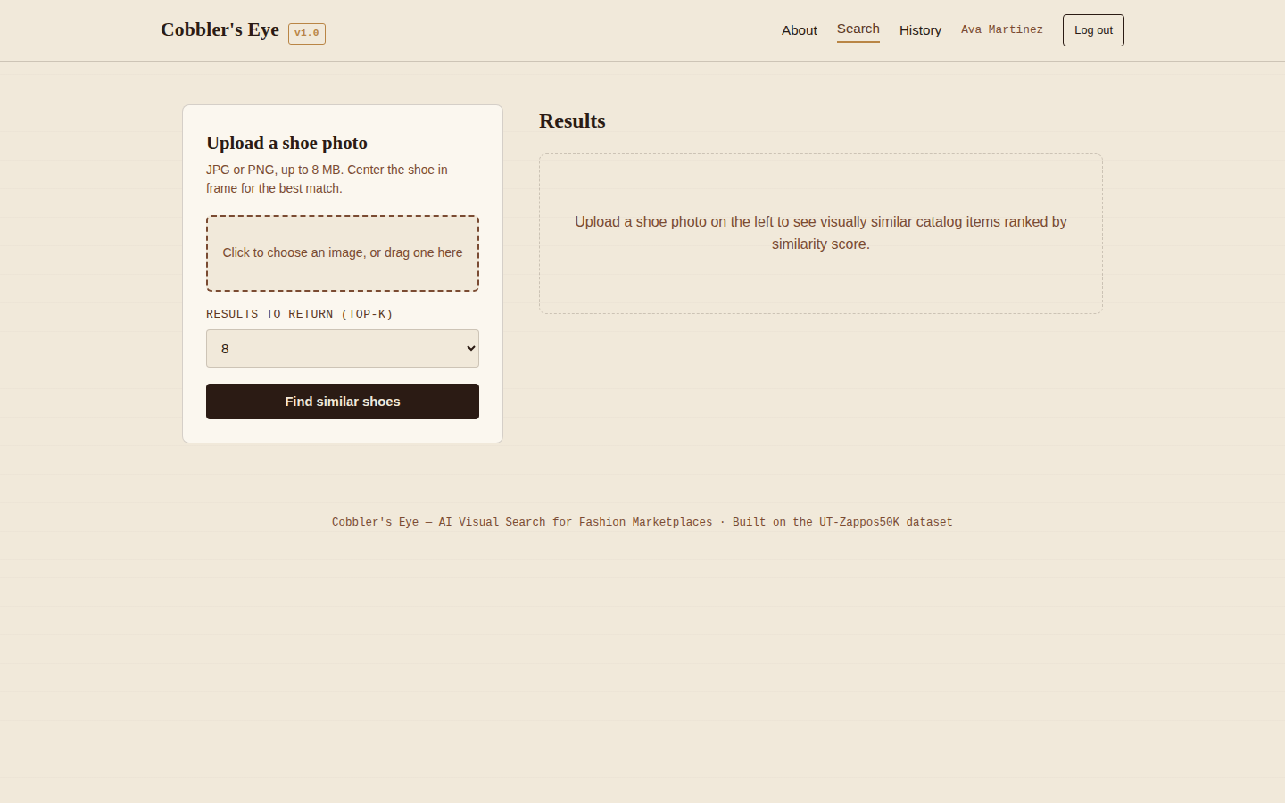
Visual search page — upload form before a query is submitted.
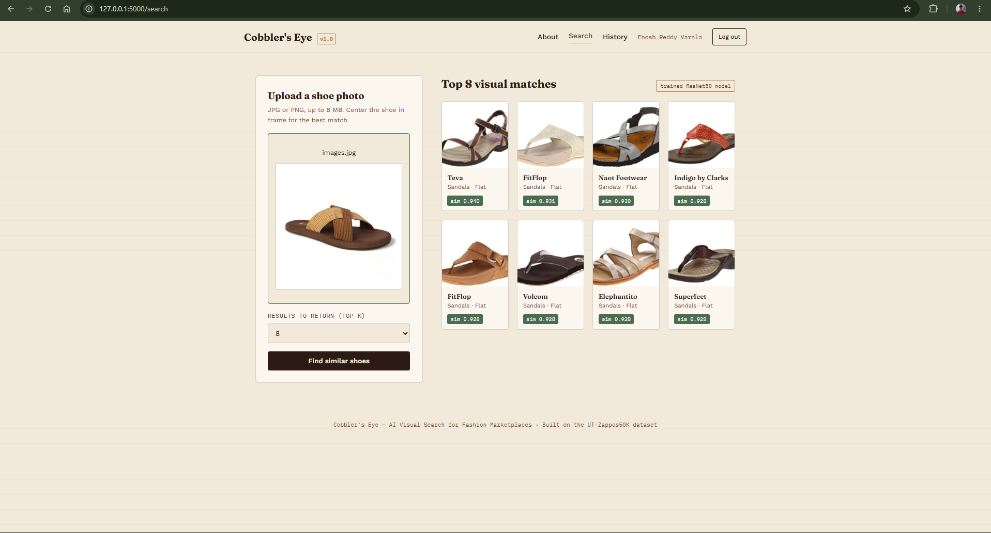
Visual search page — Top-8 ranked visual matches with similarity scores.
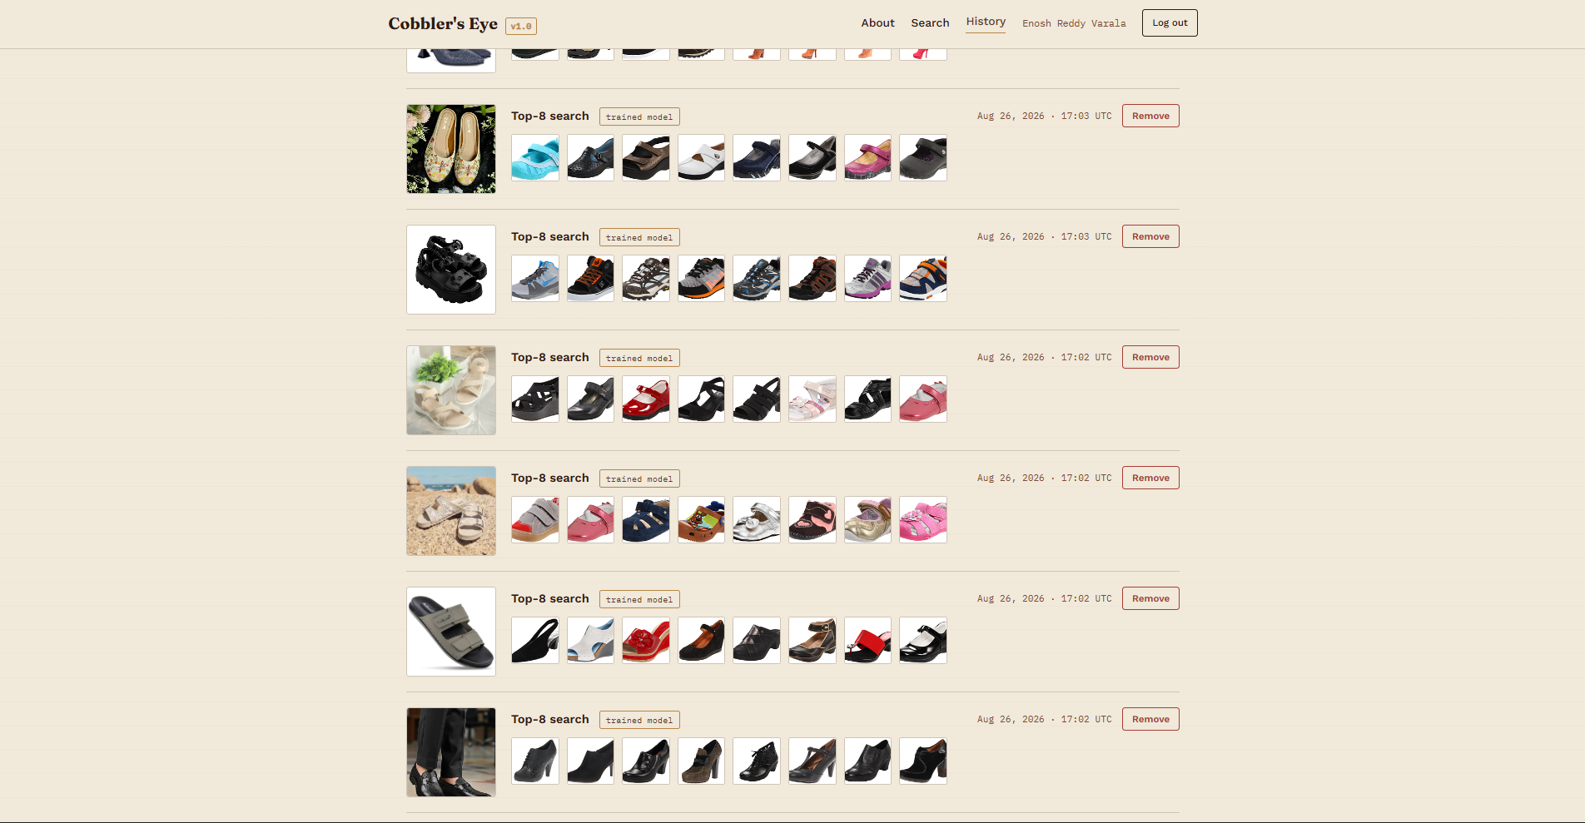
Search-history page — a logged-in user's past search with delete support.

Conclusion
Deep Learning Based Visual Search Engine successfully demonstrates the application of Artificial Intelligence and Deep Metric Learning for automated visual product retrieval in fashion e-commerce. The project integrates a pretrained ResNet-50 Convolutional Neural Network, fine-tuned with triplet loss, with a Flask-based web application to provide an end-to-end solution for finding visually similar shoes from a photo. By combining transfer learning, metric-learning training, FAISS-based similarity search, and web deployment, the system enables shoppers to upload a shoe image and receive ranked, visually relevant matches with similarity scores through a simple and intuitive interface.The project was implemented through a structured development process that included catalog construction, triplet-based dataset preparation, embedding-model training, evaluation, and application deployment. The UT-Zappos50K dataset was used to train a ResNet-50-based embedding model using triplet margin loss and partial backbone fine-tuning. Data augmentation, the AdamW optimizer, and a Cosine Annealing Learning Rate Scheduler were employed to improve embedding quality and generalization. After training, the best-performing checkpoint was integrated into a Flask web application featuring secure user authentication, drag-and-drop image upload, real-time Top-K visual search, and search-history management using SQLite — all behind a dual-mode ModelService that also runs fully in a lightweight demo configuration. The complete system provides an efficient and user-friendly platform for automated visual shoe search.

